TSDS – Superintendent Approval Form (SOA) Process

The Superintendent must approve all PEIMS submissions. This is accomplished through the Superintendent Statement of Approval (SOA) process. The Superintendent may also request an extension for one of the PEIMS submissions. All extensions must be approved by TEA. The district must have extenuating circumstances in order to receive an extension.

- Log in to TEAL and select Texas Student Data System Portal.
- On the Home screen select Prepare/Finalize Data.

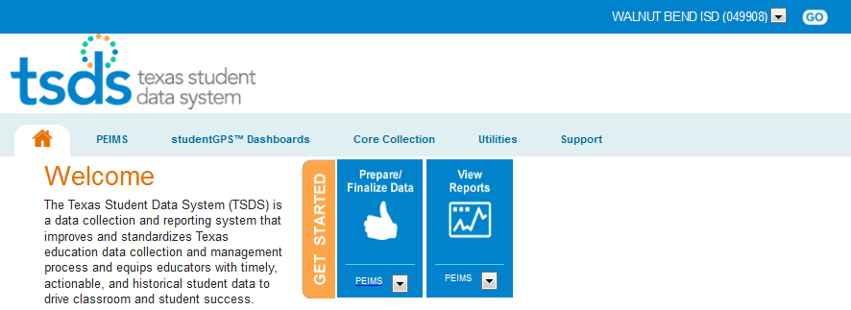

- Verify the correct collection has been selected.

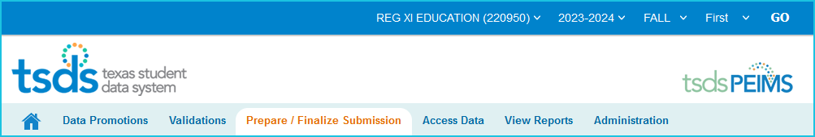
2023-2024 FALL First

- Verify the LEA Collection Status is LEA DATA ACCEPTED-ESC.

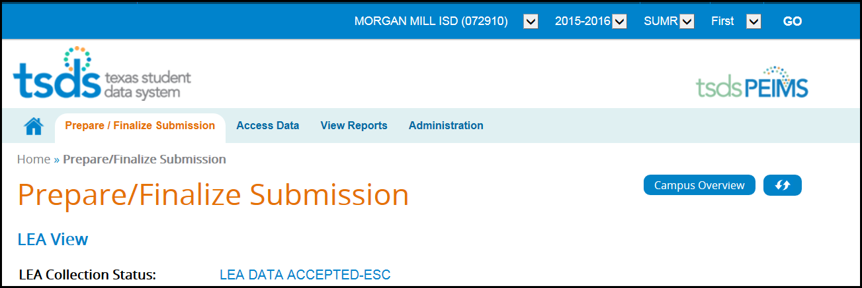

- Click on the LEA DATA ACCEPTED-ESC link to view the Status History page.

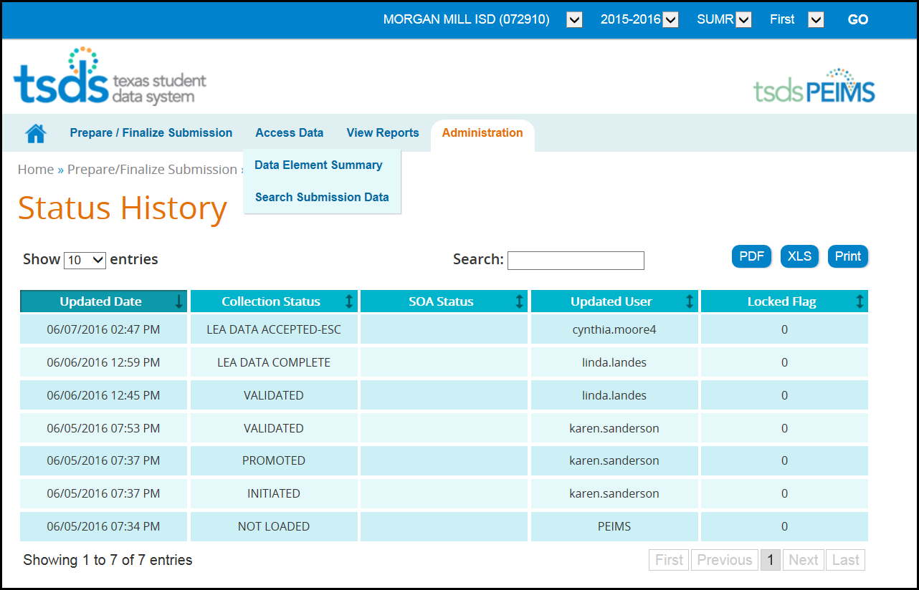

- This screen shows the dates and different status changes on the submission as well as the user that updated the data.

- Click Prepare/Finalize Submission.

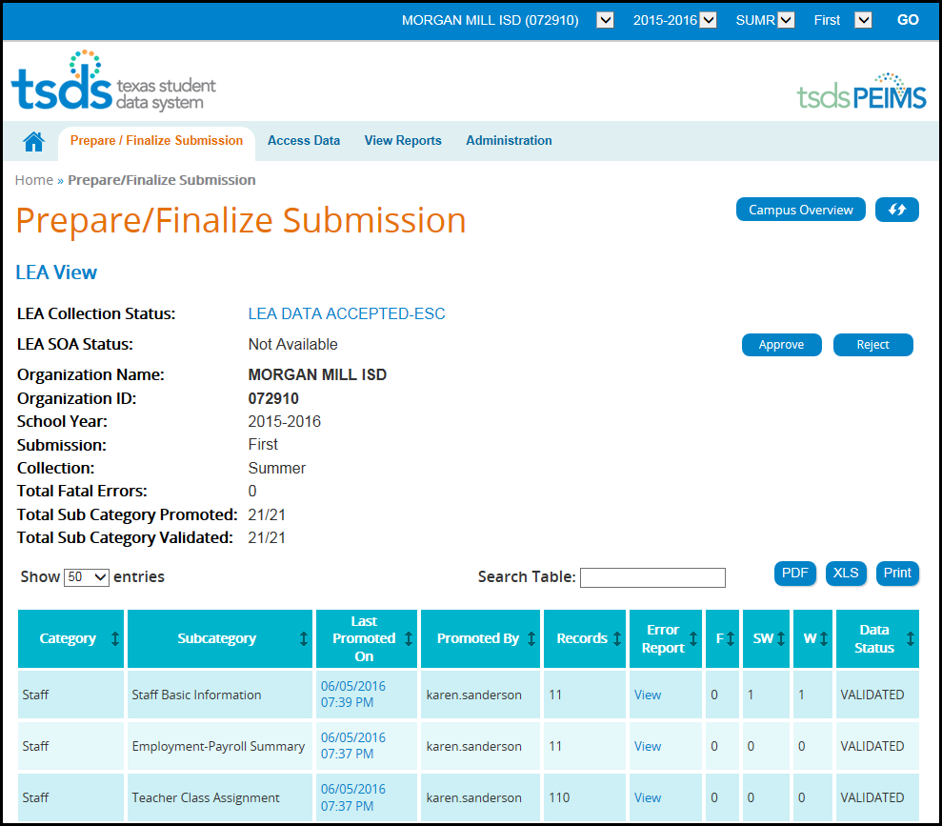

- In the Error Report column, click View to view the error reports for each category. Reports can be printed or saved as PDF or XLS.
- Verify that the Total Fatal Errors equals 0 and that the Total Subcategory Promoted and Total Subcategory Validated are the same.

- Click Approve. You will receive the SOA PDF Download.

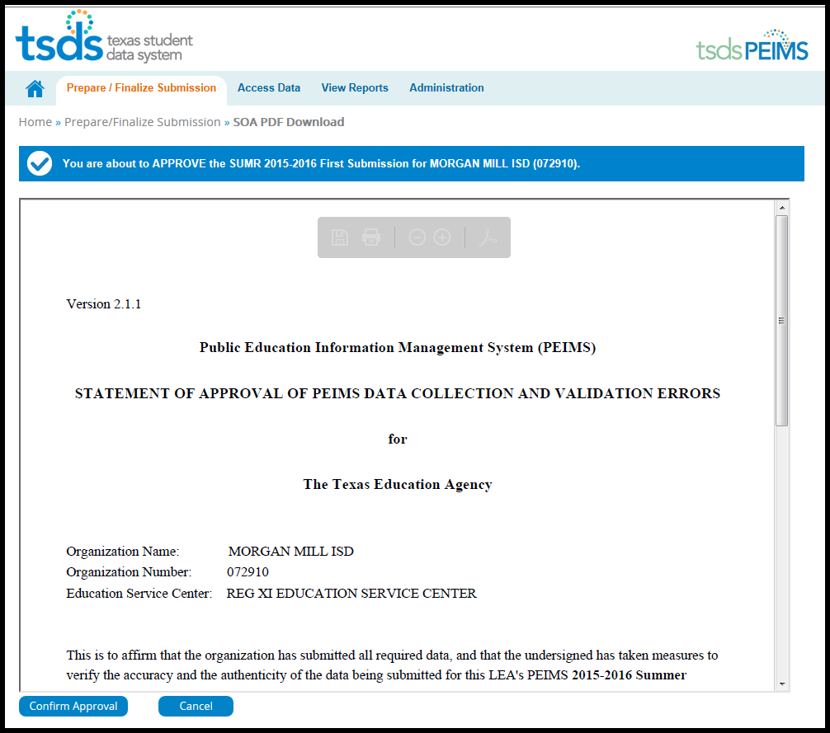

- Click Confirm Approval to continue or Cancel to cancel the process.

Please continue to next page.

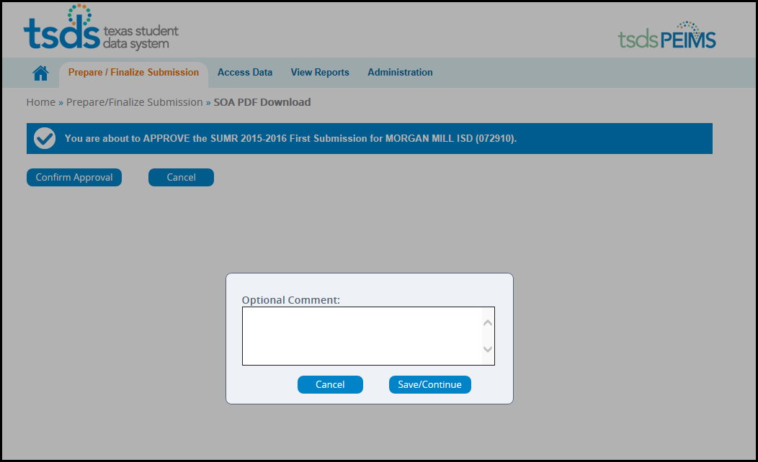

- You may enter Optional Comments in the box, but they are not required.
- Click Save/Continue to complete the process or click Cancel to stop the completion process.
- You should now see LEA DATA APPROVED-SUPT

